🧪 🔤 LAB: String Manipulation Techniques in Shell Scripting
This is a very useful Bash scripting topic 🔥
Used heavily in:
- Automation
- Log parsing
- DevOps scripts
- File handling
You’ll learn:
✅ String length
✅ Uppercase/lowercase conversion
✅ Replace words
✅ Extract text
✅ Compare strings

⚙️ Step 1: Create script
nano stringlab.sh

✍️ Step 2: Paste FULL script
#!/bin/bash

echo "🚀 String Manipulation Lab"

# =========================
# User Input
# =========================

echo "Enter your name:"
read name

# =========================
# String Length
# =========================

length=${#name}

echo "📏 Length of your name: $length"

# =========================
# Uppercase Conversion
# =========================

uppercase=${name^^}

echo "🔠 Uppercase: $uppercase"

# =========================
# Lowercase Conversion
# =========================

lowercase=${name,,}

echo "🔡 Lowercase: $lowercase"

# =========================
# Replace Text
# =========================

newname=${name/a/@}

echo "✨ Replaced string: $newname"

# =========================
# Extract Substring
# =========================

substring=${name:0:3}

echo "✂️ First 3 letters: $substring"

# =========================
# String Comparison
# =========================

if [ "$name" == "Anamika" ]
then
echo "🔥 Welcome DevOps Learner!"
else
echo "👋 Nice to meet you $name"
fi

echo "✅ String Lab Completed"
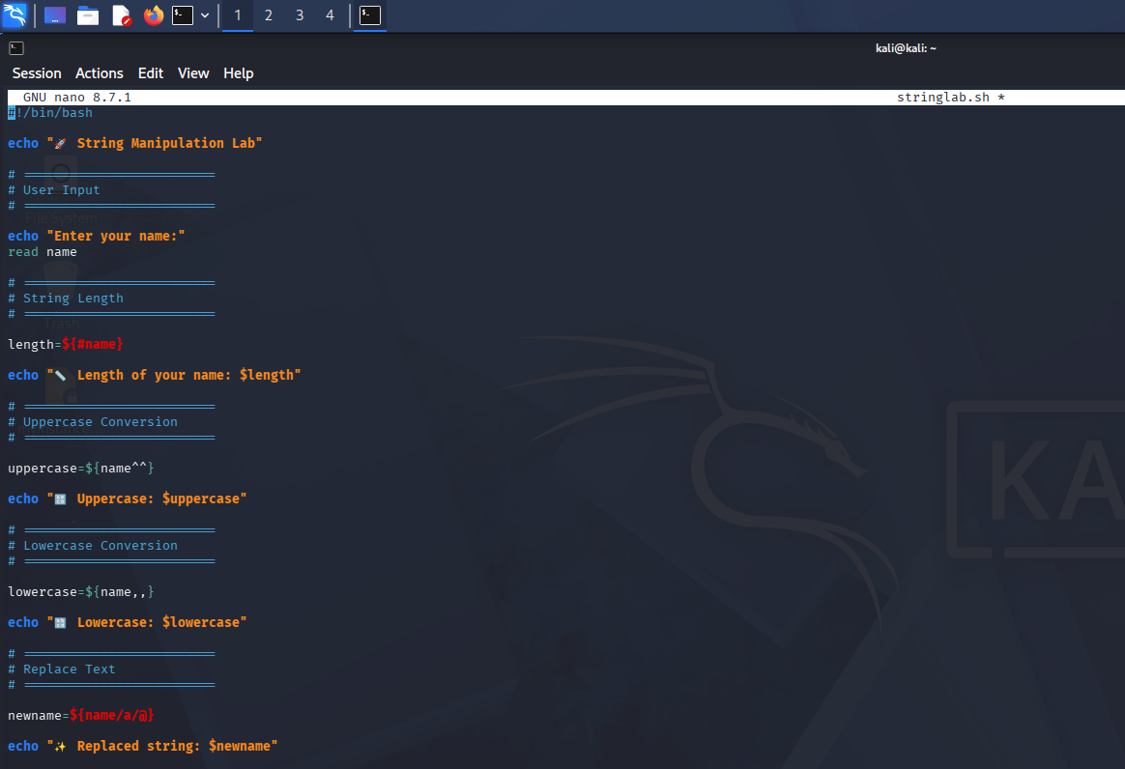
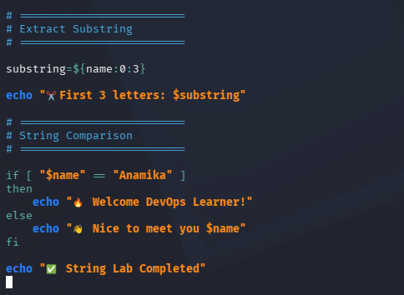

🔐 Step 3: Give permission
chmod +x stringlab.sh

▶️ Step 4: Run script
./stringlab.sh

🎯 Example Output
🚀 String Manipulation Lab

Enter your name:
Anamika

📏 Length of your name: 7
🔠 Uppercase: ANAMIKA
🔡 Lowercase: anamika
✨ Replaced string: An@mika
✂️ First 3 letters: Ana
🔥 Welcome DevOps Learner!

✅ String Lab Completed
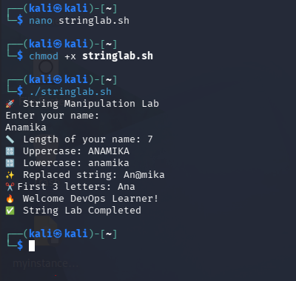

🧠 What you learned
Technique | Example
String length | ${#name}
Uppercase | ${name^^}
Lowercase | ${name,,}
Replace text | ${name/a/@}
Substring | ${name:0:3}
Compare strings | [ "$name" == "Anamika" ]

🚀 Real-world DevOps usage
Used for:
- Parsing logs
- Renaming files
- Processing usernames
- Extracting values from configs
- Automation scripts

🔥 Mini Challenge
Modify script to:
✅ Replace spaces with _
✅ Count vowels
✅ Reverse the string
nano stringchallenge.sh
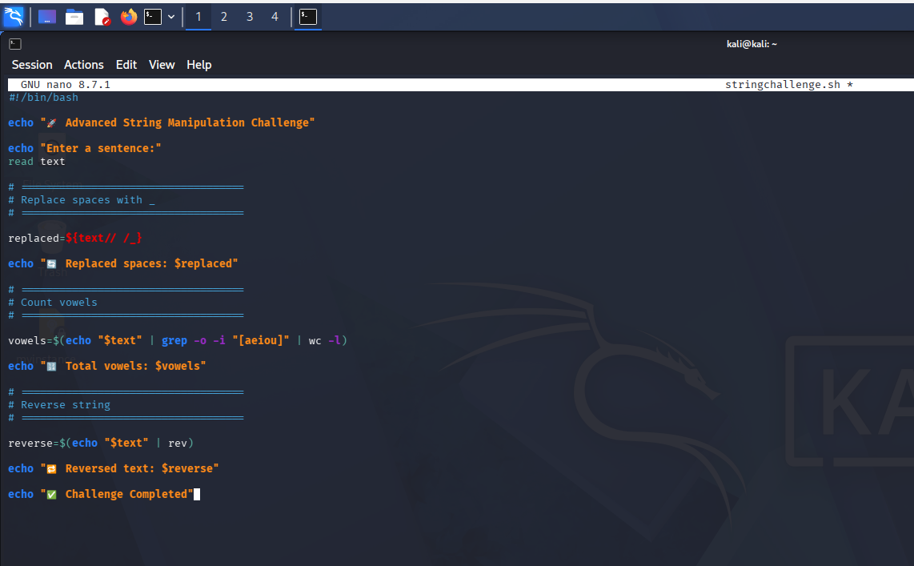
Expected output
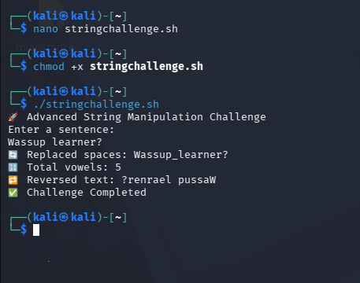

🎤 Interview-ready answer
“I’ve practiced Bash string manipulation techniques including substring extraction, replacement, case conversion, and string comparison for automation and log-processing tasks.”

